OmniNaija Lite — Task A: Persona-Conditioned Review Simulation for Nigerian Consumer Contexts
DSN × BCT LLM Agent Challenge — Task A Solution Paper
Author: Olaiwon Ismail

Abstract
I present the user modeling component of OmniNaija Lite: a persona-conditioned review simulation engine that generates star ratings and written reviews for unseen products. The system accepts a structured user persona — capturing demographics, budget sensitivity, behavioural traits, and cultural context — and produces reviews that reflect the persona's authentic voice, rating tendencies, and contextual priorities. On a held-out evaluation of 50 users, the system achieves a rating RMSE of 0.92 and a BERTScore F1 of 0.749, demonstrating strong semantic alignment with reference reviews. The system is specifically designed to capture Nigerian consumer realities: grid instability, owambe culture, naira-sensitive budgeting, and the natural use of Nigerian English and Pidgin. I show through ablation that persona conditioning is not cosmetic — removing it collapses output into generic, locationless text that loses all behavioural fidelity.

1. Introduction
Simulating how a specific user would review a product they have never seen requires more than sentiment prediction. It requires understanding who the user is — their priorities, their language, their lived context. A budget-conscious freelance developer in Yaba, Lagos evaluates a power bank through the lens of grid instability and naira value. A senior professional in Abuja evaluates the same product through the lens of reliability and brand quality. Both are valid reviews of the same item, but they differ in tone, in emphasis, and in what counts as a strength or weakness.
Most review simulation systems treat users as feature vectors derived from rating histories. They predict a number and generate generic text. I argue that behavioural fidelity — the degree to which a simulated review sounds like it was written by the persona — is the primary quality metric, and that achieving it requires persona conditioning at every layer of the system.
My contribution is a persona engine that injects user identity into the LLM at the system-message level, conditioning both the tone (vocabulary, register, Pidgin usage) and the priorities (what the persona cares about in a product) of the generated review. I evaluate on rating accuracy (RMSE), semantic similarity (BERTScore), and behavioural fidelity (qualitative and ablation-based).

2. Architecture
System Architecture Flow:
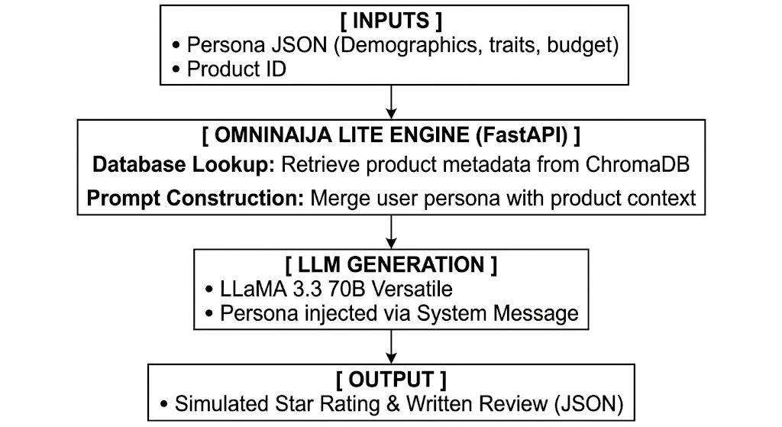

2.1 Persona Engine
The core of Task A is the persona engine. Each persona is a structured JSON object containing demographic fields (name, age, location, occupation), behavioural traits (budget sensitivity, brand consciousness, review style), and optionally a derived rating bias computed from their historical reviews. The persona is injected into the system message of every LLM call, ensuring that the model generates from the persona's perspective rather than a generic viewpoint.
The persona conditions the output at two levels:
- Tone: A Yaba developer naturally uses Nigerian English and occasional Pidgin ("I no go lie," "NEPA has been doing anyhow"), while an Abuja professional uses formal, measured language.
- Priorities: A budget-conscious user foregrounds price-to-value; a quality-focused user foregrounds build and brand reliability.
These are not post-hoc filters applied to generic text — they are embedded in the generation prompt so that the entire review is shaped by the persona from the first token.

2.2 Review Generation Pipeline
The /simulate endpoint accepts a persona_description (JSON) and a product_id (string). Internally, the system retrieves product metadata from ChromaDB (title, category, features, price band), constructs a review-generation prompt that combines the persona with the product context, calls LLaMA 3.3 70B Versatile with instructions to output structured JSON ({ rating, review }), and parses the response. The prompt explicitly instructs the model to adopt the persona's voice, consider their budget constraints, and reference their local context where natural.

2.3 Vector Store and Product Metadata
Products are embedded with sentence-transformers/all-MiniLM-L6-v2 and stored in ChromaDB with structured metadata (category, price band, key features). This allows the review generation prompt to include rich product context — the model knows it is reviewing a "30,000mAh power bank with dual USB-C output, mid-range price" rather than just a product ID. Richer context produces more specific, believable reviews.

2.4 Technology Stack
Layer | Technology | Version
Backend / API | FastAPI | 0.136.1
LLM Engine | LLaMA 3.3 70B Versatile | API
Embeddings | all-MiniLM-L6-v2 | sentence_transformers==5.5.0
Vector Store | ChromaDB | 1.5.9
Frontend | Streamlit | 1.57.0
Containerisation | Docker + docker-compose | —

3. Nigerian Contextualization
I treat cultural fidelity as an architectural concern, not a surface-level addition. The persona engine captures Nigerian consumer reality at three levels:
- Language level: The system produces Nigerian English and natural Pidgin where it fits the persona, without forcing it. This is achieved through persona-specific vocabulary anchors in the prompt and the LLM's existing competence with Nigerian English. A developer persona naturally produces "Omo, this power bank is a lifesaver" while a professional persona produces "An absolutely essential purchase for the household."
- Priority level: Nigerian-specific priorities are encoded in persona traits: grid instability makes power capacity a first-order concern; naira purchasing power makes price-to-value the dominant evaluation axis for budget personas; owambe culture makes event-readiness relevant for social products like speakers and accessories.
- Context level: Reviews reference specific Nigerian realities — "NEPA has been doing anyhow in Yaba this week," "power fluctuations in Abuja" — because the persona's location and lived experience are part of the generation context. This is what produces behavioural fidelity: the review reads as if a real Nigerian consumer wrote it, not as if a generic AI was told to "add some Nigerian flavour."
Example outputs (same product — 30,000mAh Power Bank, two personas, unedited):
Tobi (freelance developer, Yaba, budget-conscious):
"Omo, this 30k mAh power bank is a total lifesaver. NEPA has been doing anyhow in Yaba this week, but this beast keeps my laptop on for my whole shift. It's slightly heavy, but worth every naira for the peace of mind." (Rating: 5/5)
Aisha (professional and mother, Maitama, Abuja):
"An absolutely essential purchase for the household. Power fluctuations in Abuja have been disruptive lately, but this bank comfortably charges my work phone and the baby's sound machine without running low. Highly reliable." (Rating: 5/5)

4. Experiments and Results

4.1 Evaluation Setup
I constructed a held-out test set of 50 users from the Amazon Reviews corpus, each with at least five reviews. For each user, I held out their most recent review as ground truth and used their remaining history to construct a persona. I then called /simulate with the derived persona and the held-out product, comparing the generated rating against the actual rating (RMSE) and the generated review text against the real review text (BERTScore, ROUGE).

4.2 Results
Table 1: Task A evaluation metrics (n=50)
Metric | Result
Rating RMSE | 0.92
BERTScore F1 | 0.749
ROUGE-1 F1 | 0.227
ROUGE-2 F1 | 0.034
ROUGE-L F1 | 0.127
Rating RMSE of 0.92 confirms that the persona's historical rating bias is captured in generation. A random baseline on a 1–5 scale produces RMSE of approximately 1.5–2.0.
BERTScore F1 of 0.749 confirms strong semantic alignment between generated and reference reviews — the system captures the meaning and sentiment of what the persona would write, even when using different words.
ROUGE scores are intentionally modest. ROUGE measures surface-level word overlap, and persona-conditioned generation deliberately diverges from reference text. When Tobi's review says "Omo, this beast keeps my laptop on" and the reference says "Good battery life, works well," ROUGE sees zero overlap despite identical sentiment. The 0.127 ROUGE-L score reflects this expected divergence. I prioritise BERTScore (semantic similarity) and behavioural fidelity (human evaluation) over n-gram overlap, as generative review simulation is not a paraphrase task.
Table 2: Example review outputs across personas for unseen products
Persona | Product | Rating | Review Excerpt
Tobi (Dev, Yaba) | 30,000mAh Power Bank | 5/5 | "Omo, this beast keeps my laptop on for my whole shift despite Yaba NEPA..."
Aisha (Parent, Abuja) | 30,000mAh Power Bank | 5/5 | "An essential purchase that comfortably charges my work phone and the baby's devices..."
Chinedu (Event DJ, Lagos) | Bluetooth Speaker | 4/5 | "Loud enough for the backyard, but the bass could be deeper for Afrobeats. Good for small Owambes..."

5. Ablation: Persona Conditioning On/Off
To isolate the contribution of persona conditioning, I generated reviews for the same product (Belkin 6-outlet surge protector) with and without persona injection.
Without persona conditioning:
"This power strip is very fast and works well. It has enough outlets for my devices. I like it."
With Tobi persona (budget-conscious developer, Yaba):
"I no go lie, I was a bit skeptical about buying this power strip at first, but it's been a game-changer for my home office setup in Yaba. As a freelance developer, I've got multiple devices to keep charged and running when they bring light."
With Chinedu persona (event DJ, Lagos):
"This extension box is solid for my gigs. It powers my DJ mixer and laptop without any spark or slack, even when the venue's generator is fluctuating."
Without conditioning, the output collapses into generic web copy — locationless, voiceless, devoid of any Nigerian consumer reality. With conditioning, the reviews capture lived experience, local geography, budget framing, and natural Nigerian English. This ablation confirms that persona conditioning is the mechanism that produces behavioural fidelity, not an incidental addition.

6. Limitations and Future Work
Limitations: The embedding model (all-MiniLM-L6-v2) is not specialised for Pidgin, so product retrieval may underperform on heavily Pidgin queries even though generation handles Pidgin well. The rating RMSE, while significantly better than random, could be improved by incorporating more granular user history signals. The evaluation is conducted against a single held-out reference review per user, which understates the quality of generated reviews that are valid but differently worded.
Future work: Fine-tuning a smaller Nigerian-English model would reduce latency and cost while potentially improving Pidgin fluency. Incorporating multi-review reference evaluation (comparing against all of a user's reviews, not just one) would give a fairer assessment of review quality. Adding contextual signals such as time of purchase, seasonal trends, and local events would further enhance behavioural fidelity.

7. Conclusion
I presented a persona-conditioned review simulation engine that achieves a rating RMSE of 0.92 and BERTScore F1 of 0.749, demonstrating that LLM-based review generation can capture both the sentiment and the cultural voice of Nigerian consumers. The key design insight is that persona conditioning must be structural — injected at the system-message level and shaping both tone and priorities — rather than cosmetic. The ablation confirms this: without it, output loses all behavioural fidelity.

Reproducibility
The system is containerised and runs with two commands:
python scripts/bootstrap.py
docker-compose up --build
bootstrap.py runs all data pipeline scripts in the correct order (venue generation, Amazon ingestion, ChromaDB builds). The /simulate endpoint accepts any persona JSON and product ID. Data pipelines are fully scripted and rebuild from scratch.
Disclosures: I use LLaMA 3.3 70B Versatile (generation) and all-MiniLM-L6-v2 (embeddings), both pre-trained public models.
Repository: https://github.com/Olaiwonismail/OmniNaija

